Mount Waverley Water Main Renewal Project

Safety barriers installation -night works

We will be conducting barrier movement around our work areas as the project progresses Eastwards.

To safely do this we will have to conduct a full road closure on High Street Road between Stewart Street and Lee Avenue. These works will be carried out at night when traffic movement is at its lowest.

**When:** Sunday 18 and Monday 19 February 2024

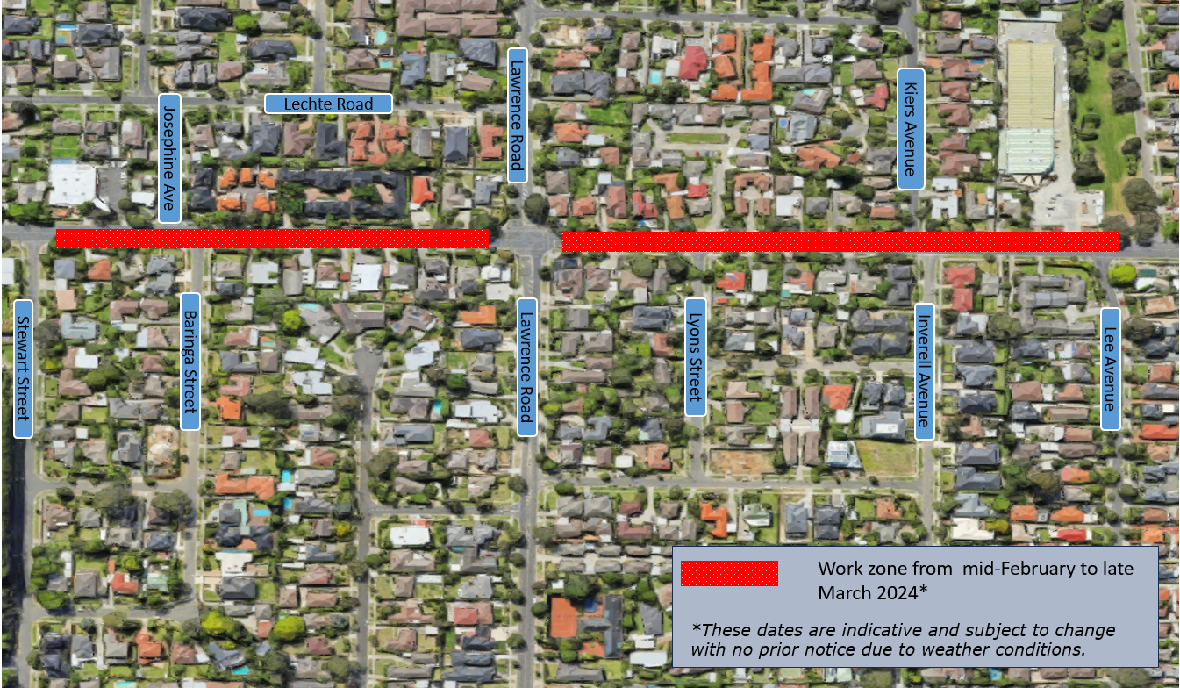**Time:** 10pm – 5am

Figure 1: Current and upcoming work zones

Figure 1: Map on High Street Road Closure

# What can you expect.

1. Footpaths will remain open with detours. Driveway access will be maintained for High Street Road residents.
2. Traffic management will be in place to assist motorists, cyclists and pedestrians around the area.
3. Bright lights will be used during night works. Where possible, lights will be directed away from neighbouring property windows.
4. Noise from construction equipment, construction activities and large vehicles.
5. Changes to the way you travel. Do allocate extra travel time during the period.
6. Access for emergency service vehicles will be maintained at all times during these works.

# Route 734 bus stops

To ensure the safety of commuters, bus stops within the work site area will close until it is safe to re-open. Please use neighbouring bus stops during this time.

Please be aware that works can sometimes take longer than expected or need to be rescheduled due to weather and other factors outside of our control.

Keep in mind there are other ongoing works being conducted in the area by Monash Council and Yarra Valley Water.

Melbourne Water appreciates your support and understanding while these works are carried out.

